



**Disclaimer: The content is curated from online/offline resources and used for educational purpose only**

**LAB MANUAL**

**Unit III – Machine Learning**

**Unit III – Machine Learning**

**Lab 7. Optimize the integration of predicted solar and wind energy into the power grid**

**Objective**

The objective of this project is to optimize the integration of renewable energy sources, specifically solar and wind power, into the power grid using K-Means clustering. By clustering the energy outputs from solar and wind sources over time, we aim to identify distinct patterns of energy generation. These patterns will allow for more efficient management of the energy grid by predicting periods of high or low energy generation and making better use of renewable resources.

**Problem**

With the increasing share of renewable energy sources like solar and wind in the global energy mix, integrating these intermittent energy sources into the power grid efficiently becomes a major challenge. Solar and wind energy outputs fluctuate depending on time of day, weather conditions, and seasonal factors, creating uncertainty in energy production.

**Solution**

To create the Classifying Waste Types for Recycling (to classify them into different categories: Plastic, Metal, Organic, ) using classification algorithms

following steps:

1. Import required libraries
2. Prepare the dataset
   1. Load Dataset
   2. Select features and normalize the data
3. Elbow Method to find the optimal number of clusters
4. Create and Train the Model
5. Evaluate the model performance
6. Visualization

**Procedures**

**1. Import required libraries**

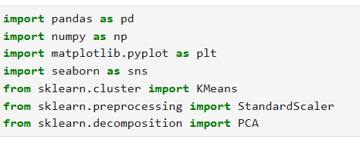

**2. Prepare the dataset**

**2.1 Load Dataset**

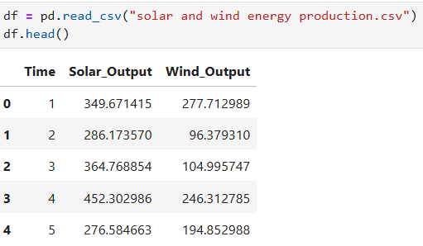

**2.2 Select features and normalize the data**





**3. Elbow Method to find the optimal number of clusters**

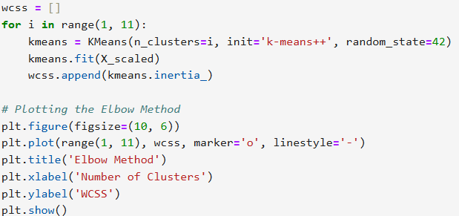

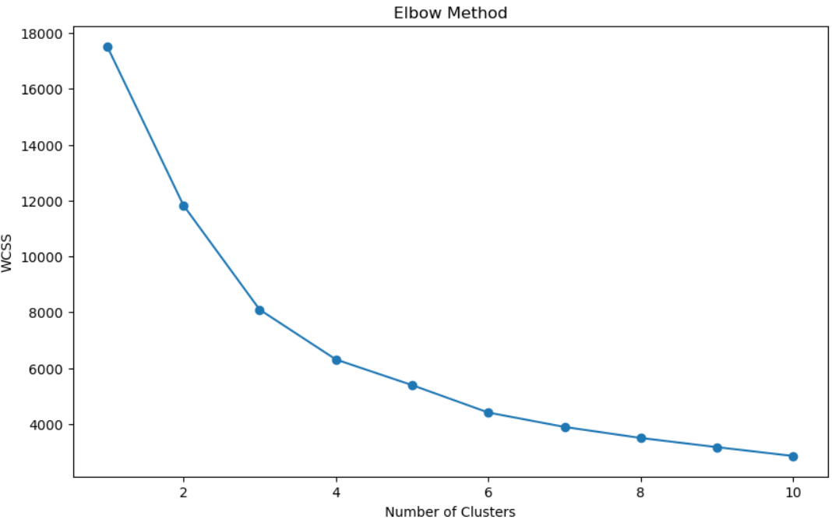

**4. Create and Train the Model**

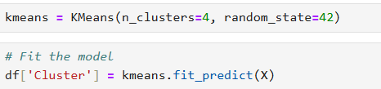

**5. Evaluate the model performance**

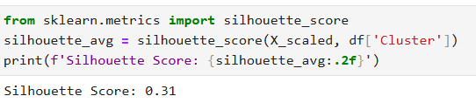

**6. Visualization**

